**READ A NUMBER AND SQUARE:**

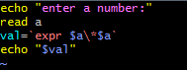

**OUTPUT**

